Curriculum Overview for Early Years
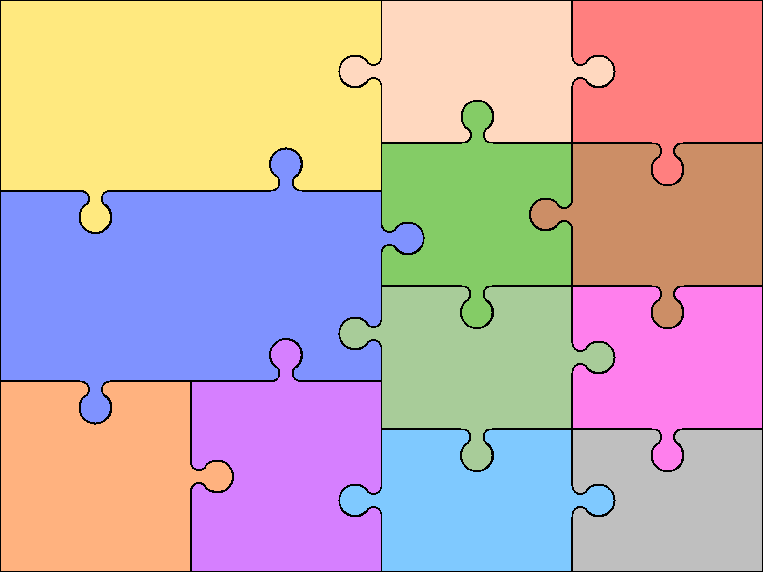  what the children would do  - Retell stories  - Predict events  - Talk in front of a group  - Sequence events  - Maintain attention and listen carefully  - Ask questions  - Use story book language in their play. | Communication for Language  ELG:Children express  themselves effectively, showing awareness of listeners’ needs. They use past, present and  future forms accurately when talking about events that have happened or are to happen in the future.  They develop their own narratives and explanations by connecting ideas or events. |  | Themes taught in the Early Years  - Colour  - Julia Donaldson  - Animals  - Toy Story  - Around the world  - People who help us | Literacy  What the children do  - Write cvc words independently  - Write simple sentences independently  - Applying phonic knowledge to read cvc words in reading books | Early Learning Goal  - ELG:Children read & understand simple sentences. They use phonic knowledge to decode regular words & read them aloud accurately. They also read some common irregular words. They demonstrate understanding when talkingwith others about what they  have read.  ELG:Children use their phonic knowledge to write words in  ways which match their spoken sounds. They also write some irregular common words. They write simple sentences which canbe read by themselves & others. Some words are spelt correctly & others are phonetically plausible
 |  |  |  | Maths  What the children do  - Can order and recognise numbers 1-20, find 1 more or less using counters initially.  - Write down calculations  - Find half of numbers, an object  - Double numbers, objects.  - Order objects by size, weight, height.  - Look at time of day and routines, start to tell the time.  - Know different coins, continue patterns and know shapes they see around them. | Early Learning Goal  - ELG: Children count reliably with numbers from one to 20, place them in order and say which number is one more or one less than a given number. Using quantities & objects, they add & subtract two single‐ digit numbers & count on or back to find the answer. They solve problems, including doubling, halving & sharing.  ELG Children use everyday language to talk about size, weight, capacity, position, distance, time and money to compare quantities and objects and to solve problems. They recognise, create & describe patterns. They explore characteristics of everyday objects & shapes & use mathematical  language to describe them.
- Share with their friends  - Talk to each other nicely  - Make friends  - Have a go at new things  - Asking for help  - Show good behaviour  - Work with other children in their class  - Talk to adults and children differently.  - Say how they feel | Personal and Social  What the children do  - Empathy for friends and situations. |  | - ELG:Children talk about how they and others show feelings, talk  - about their own and others’  - behaviour, and its consequences, &know that some behaviour is  - unacceptable. They work as part  - of a group or class, & understand & follow the rules.  - They adjust their behaviour to  - different situations, & take  - changes of routine in their stride.
 |  |  |  | Understanding the world  What the children do  - Talk about what happens at home and what is important in their lives.  - Talk about what they like and how they are different from other children.  - Look at plants, frogs and chicks life cycles.  - The seasons, weather  - Use a mouse to open a computer programme. | Early Learning Goals  - ELG: Children talk about past & present events in their own lives& in the lives of family members. They know that other children don’t always enjoy the  same things, & are sensitive to this. They know about similarities & differences between themselves & others, &among families, communities &  traditions  . ELG :Children know about similarities & differences in relation to places, objects, materials & living things. They talk about the features of their own immediate environment& how environments might vary  from one another. They make observations of animals & plants& explain why some things occur, & talk about changes
Physical  What the children do  - hold a pencil correctly  - move their bodies around, under in and out of equipment.  - Use their fingers to roll, pat, squash  - use tools such as paint brushes, play dough tools.  - What are healthy foods?  - How exercise helps their body  - Use the toilet  - Get dressed  - Throwing and catching  - Pencil rolls, forward rolls  - Dance  - Gym |  | Early Learning Goal  - ELG:Children show good control &  co‐ordination in large & small  movements. They move confidently in a  range of ways, safely negotiating space. They handle equipment & tools  - effectively, including pencils for writing  - ELG:Children know the importance for  - good health of physical exercise, & a  healthy diet, & talk about ways to keep healthy & safe. They manage their own basic hygiene & personal needs  successfully, including dressing & going  to the toilet independently.
 |  |  |  | Expressive Arts and Design  - sing songs, dance, act out stories.  - use paint, glue, junk modelling to make models and creations. Talk about the texture of materials that the see and feel.  - Experiment with colours.  - Use different techniques to fasten models together. Use cellotape for reasons instead of glue and talk about it. | Early Learning Goals  - ELG: Children sing songs, make music & dance, & experiment with ways of changing them. They  safely use & explore a variety of materials, tools & techniques, experimenting with colour, design, texture, form & function.  - ELG: Children use what they have learnt about media and materials in original ways, thinking about uses & purposes. They represent their own ideas, thoughts & feelings through design & technology, art, music, dance, role play & stories

